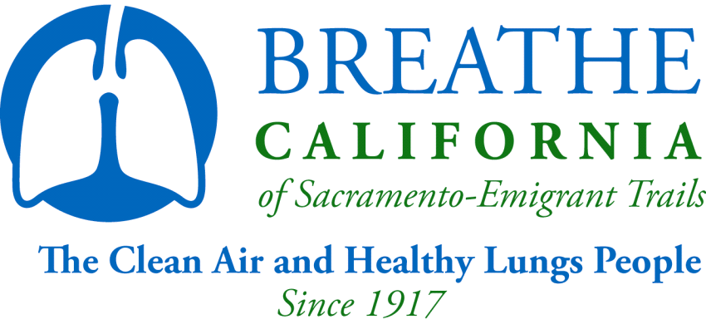
2015-16 Youth Advisory Board Member Application
Breathe California of Sacramento-Emigrant Trails
916-444-5900
YAB Application
Due by: May 15th, 2015

Name: ____________________________________________________ Date ___________________
last first middle initial

Name of School: __________________________________________

Grade in 15/16

School Year: __________________________________________

Birthday: _____ - _____ - _____

Mailing Address: _______________________________________________

__________________________________________________
city state zip code

County:
Home Phone Number (____)_______ - ___________ Email_______________________________
Cell Number (____)_______ - ___________
ETHNICITY (optional)
Caucasian ___ Asian/Pacific Islander___
Native American___ African American___
Hispanic/Latino___ Other___
On the back of this form or on an additional page please type or print clearly answers to the following questions:
1. Why do you want to become a member of the Youth Advisory Board?
2. What skills can you bring to the Youth Advisory Board?
3. In what Breathe California (or other community) programs have you been a leader in?
4. What are your interests and hobbies?
5. What other organizations/programs are you involved in?
***Please include a resume with your application packet***
Return completed application and current transcript by May 15th, 2015 to:
Breathe California of Sacramento-Emigrant Trails
Attn. Selection Committee c/o Natalie Lanning
909 12th Street Sacramento, CA 95814

Youth Advisory Board: Letter of Agreement

Breathe California of Sacramento-Emigrant Trails’ mission is clean air, healthy lungs and the elimination of lung disease.
_________________________________’s term will be from August 1, 2015 to June 30, 2016

Breathe California of Sacramento-Emigrant Trails; The Clean Air and Healthy Lungs People expects the following from you as a Youth Advisory Board member:
- Attend an orientation meeting at the beginning of your term
- Attend 6-8 Youth Advisory Board meetings throughout the 2014-2015 year from August 2015-June 2016. If you miss more than 2 meetings without contacting Youth Advisory Board staff, you may be asked to resign from the board.
- Communicate regularly and timely with staff
- Attend at least one Board of Directors’ meeting during the 2015-16 term.
- Serve on a minimum of one committee. Most committee activities will require meeting outside of the regular YAB meeting time.
- Actively assist and advise the organization in the areas of youth program development and management.
- Be available and eager to represent the organization in various settings.
- Be active advocates for the association’s mission.
- Work with staff, Board of Directors, and fellow members to define and monitor the implementation of our mission, goals and values.
- Maintain a 3.0 GPA in all schoolwork. Please submit a current transcript with this agreement. You may be asked to submit current transcripts 1-2 more times during the year.
- To evaluate your experience and the activities of the Youth Advisory Board at the end of your term.

What Youth Advisory Board members may expect from Breathe California of Sacramento-Emigrant Trails:
- Respectful use of your time. The asset of time is one of the most critical resources busy people like you have. We commit to using your time in a manner that will return value to your personal contribution.
- Supply appropriate training to you to become an active leader and team player in our community.
- Offer you community service credit when appropriate.
- Get important information to you in a timely manner.
- An interesting, exciting and valuable experience.

__________________________
Signature of Member

__________________________
Date

-Please complete parental agreement on back page-

Breathe California of Sacramento-Emigrant Trails
909 12th Street, Suite 100
Sacramento, CA 95814
916-444-5900

Youth Advisory Board: Letter of Agreement page 2

Parental Agreement

I hereby give my son/daughter, ________________________, permission to participate in the Youth Advisory Board and related Breathe California of Sacramento-Emigrant Trails’ activities and will make sure they are available for trainings and meetings. I release and hold harmless Breathe California of Sacramento-Emigrant Trails, its employees and constituents from all liability involved from my son/daughter participating in this project and subsequent project activities.

Date__________ Parent/Guardian(s) (please print)__________________________

Parent/Guardian Signature(s)____________________________________________

Phone number where Parent/Guardian can be reached______________________________

Breathe California of Sacramento-Emigrant Trails Photo Release

- I give to the Breathe California of Sacramento-Emigrant Trails, its nominees, agents and assigns, unlimited permission to use, publish and republish for purposes of advertising trade, or any other lawful use, information about me and reproductions of my likeness (photographic or otherwise) and my voice, whether or not related to any affiliation with Breathe California of Sacramento-Emigrant Trails, with or without my name.

Name of person to be photographed or recorded (Please Print) | Age (if minor)
Street address, city, state, and zip code

Signature | Date

- Consent of parent or legal guardian if above individual is the minor.

I consent and agree, individually and as parent or legal guardian of the minor named above, to the forgoing terms and provisions.

Signature | Date

YOUTH ADVISORY BOARD: JOB DESCRIPTION
The Youth Advisory Board is a leadership opportunity for students to utilize and further develop management, public speaking, and other professional skills. Through active participation by its members the Youth Advisory Board: Expands Youth Involvement to enhance our goals of clean air, healthy lungs, and the elimination of lung disease.

The Youth Advisory Board will represent Northern California youth and will increase youth involvement in all areas of our organization.

Qualifications

- Be between the ages of 14 and 21 years old
- Maintain a GPA of at least 3.0
- Attend monthly Youth Advisory Board meetings which include an orientation meeting and a joint meeting with the Breathe California of Sacramento-Emigrant Trails Board of Directors. Meetings will be held between August 2015 and May 2016
- Be able to provide your own transportation to and from Youth Advisory Board Meetings and activities/events
- Represent Breathe California of Sacramento-Emigrant Trails as a non-smoker

Specific Responsibilities

Serve as ambassadors to schools/community
- Support the inclusion of mission-based programs on respective school campuses
- Create awareness of our mission, programs and goals among peers and the community in general

Carry out the “youth voice” for our youth programs
- Serve as spokespersons for youth programs
- Attend program meetings in which the member is an active participant (ie. Thumbs Up! Thumbs Down!)
- Have the opportunity to assist with special events/fundraisers
- Work with the Board of Directors and Breathe California of Sacramento-Emigrant Trails Staff on programs and event development, advocacy, outreach/ networking, and all other areas that impact our mission

Serve on a YAB Committee
- Must serve on one committee (can serve on more than one)
- Attend and actively participate in committee meetings
- Actively participate in planning committee activities

Contribute to Breathe Programs/Events
- Commit to 5 specific program/event actions

